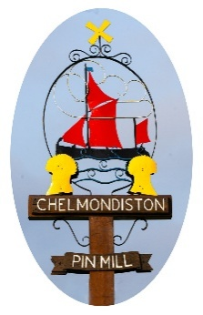
Chelm Chelmondiston Parish Council
The Village Hall, Main Road, Chelmondiston IP9 1DX

Parish Clerk: Ms Katie Davies e-mail: clerk@chelmondiston-pc.gov

Newsletter. May 2026

Dear Parishioners,
We are looking for a new Councillor. Sadly we had to say good bye to one of our newer Councillors earlier this spring. With him, we lost an enthusiastic supporter of the parish who was prominent in securing our Speed Indication Devices and looking after some of our IT. He was also part of the Pin Mill regeneration working group.
Have you got what it takes? We need someone who either lives in the parish or has a close connection with it (eg. by working here), who cares about what happens to our assets and our environment and who is willing to offer a small amount of time for the benefit of the community so that this continues to be a thriving place in which to live. The Council meets usually on the first Tuesday of each month, though not normally in August. Have you got particular skills or experience to offer your community? Or maybe you are just keen to see what we do and help in unspecified ways?
The Annual Village Meeting takes place next week on Tuesday 19th May in the Village Hall, starting at 7.00pm. This is not a Parish Council meeting, rather it is a chance for local people and activity groups to report on what they have done over the past year and discuss items of interest to all of us. Why not come along and hear what your Parish Council has been doing for you, what other things are going on in the community, and have your say?

Best wishes,
Cllr. Rosie Kirkup, Vice-Chairman.
Emails: rosiekirkup@chelmondiston-pc.gov.uk
or clerk: clerk@chelmondiston-pc.gov.uk

