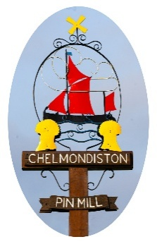
Chelm Chelmondiston Parish Council
The Village Hall, Main Road, Chelmondiston IP9 1DX
Chairman: Cllr Rosie Kirkup
Parish Clerk: Ms Katie Davies e-mail: clerk@chelmondiston-pc.gov

COUNCIL NEWS Autumn 2025

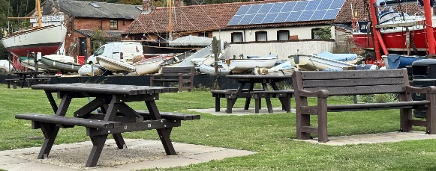
Dear Parishioners,
We hope you had an enjoyable summer.
The Parish Council is delighted to report that the new furniture has arrived and been positioned on the Common at Pin Mill, together with the new noticeboard which was put up a few weeks ago. We will shortly be planting an oak tree, gifted by a resident. The benches and tables from Pin Mill have been gifted to the Playing Field. This work would not have been completed had it not been for the hard work of several of your Councillors.
Following a trouble-free audit this year, thanks largely to our Responsible Finance Officer, we can now look ahead. Autumn tasks include starting to work on our budget for the year 2026-2027. We have formalised several of the ad hoc gardening tasks around the village and now have a regular gardener for the Jubilee Garden, another who trims the plants at the Village Hall and will from next year be doing regular strimming of the mini-orchard area in Pin Mill Road, as it has lately been rather a jungle! For those of you who didn’t know – the fruit trees here were planted by the Parish Council and are there for all to enjoy and pick the fruit as and when it appears. We will take a further look at the contract for footpath strimming and probably add a few more visits at the height of the season as this year’s growth has exceeded expectations.
Those of you who hold allotments in Pin Mill Road may have been concerned following rumours that the land was about to be sold for development. We have been assured by the heirs of the previous owner of this land that they have no intention of making any changes for at least the next two years, so the allotments can carry on as usual for the time being. The Council is looking into how it might help secure the future of this valuable resource.
If any of you have views on how to improve the garden area of the Village Hall, we would like to hear from you (preferably by email – see below) because we are considering, in conjunction with the Village Hall Committee, how to improve the frontage of the hall at the same time as providing better wheelchair access. We would be looking for grant funding to do this, but could partly fund the work from the Community Infrastructure Payments we have received from new developments in the parish.

Best wishes, Rosie Kirkup, Chairman.
Emails: rosiekirkup@chelmondiston-pc.gov.uk or clerk: clerk@chelmondiston-pc.gov.uk

